Type-C Multi-Function Compact Docking Station
4K HDMI + Gigabit LAN + 2 Port USB3.0 + SD Card Slot + PD Charge Port
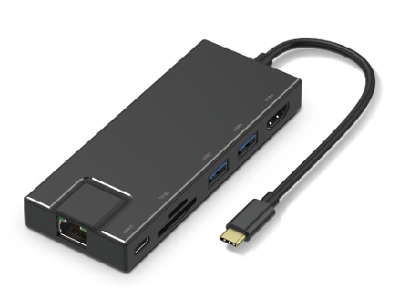

C-TC-DK-HDMI

Descrption:
Ultra-compact, the must-have Type-C docking station for your Type-C MacBook ProTM, ChromeBookTM DellTM XPS and other notebook or desktop computers with the next generation Type-C ports.
Instantly connect an external 4K HDMI monitor, TV or projector. Connect to your wired Gigabit Ethernet LAN, use USB keyboards, mice and external USB3 storage devices, simultaneously and without any loss of speed or performance. Need to download photo's from an SDTM card? Built-in SDTM card read and writer means you have full control of your digital lifestyle - with style!

Features:
7-in-1 USB C HUB:
This USB-C HUB includes 1 HDMI port, 1 RJ45 ethernet port, 1 USB Type-C PD Charging Port, 1 SD/ TF Card Reader and 2 USB 3.0 ports to Your MacBook and Type-C laptops.

PD Function:
This female type C port support PD charging up to 60W.This multiport USB C adapter provides one USB C pass through female port by which you could charge connected MacBook pro or other Type-C laptops.

4K HDMI Port:
HDMI port can mirror or extend the screen from your Macbook or other USB C laptop without HDMI port to a monitor, or projector. Resolution reaches 4K 30Hz

Data Transfer:
Via 2 USB 3.0 ports,You can connect U disk,Keyboard and Mouse to your Macbook or other USB C laptop.The build in SD/TF Card slots support 2 cards reading simultaneously.

Compact and portable:
Macbook Pro USB C HUB is light and compact, you can put it in your pocket easily. You can conveniently take it on-the-go for business travel and more.

SPECIFICATIONS
- Interface Type:USB 3.1
- Product name: TYPE-C HUB
- Cable:160mm
- Color: Black , Gray
- Material: Aluminum Alloy
- Ports:7
- Certification: CE,FCC,RoHS
- Interface:USB-C to HDMI,Ethernet,2 USB3.0,SD/TF Card slot,usb-c charge
- Lead Time：
Quantity(Pieces) | 1 - 300 | >300
Est. Time(days) | 7 | To be negotiated

Product Code:
Barcode ：8400800036520
Size: 118x46x160mm

